After Installing: Configuring With MySQL
DerbyNet uses a database to store all the data for each event. In most cases, choosing SQLite as the database engine is somewhat simpler than using a MySQL database. (See http://www.sqlite.org/whentouse.html for some additional discussion.)
This document describes configuring the DerbyNet site with a MySQL database.

Set Up Database

Create Database File
If you've just installed DerbyNet, you can visit http://localhost, which should redirect to http://localhost/database-setup.php, and see that you don't yet have a configuration file:
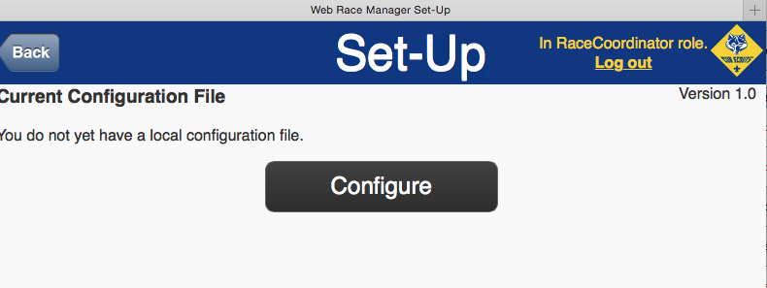
If you've already done this once, and now you want to switch to a different configuration, just visit http://localhost/database-setup.php explicitly. Alternatively, if you delete the configuration files in the local directory, DerbyNet will once again be in a just-installed state.
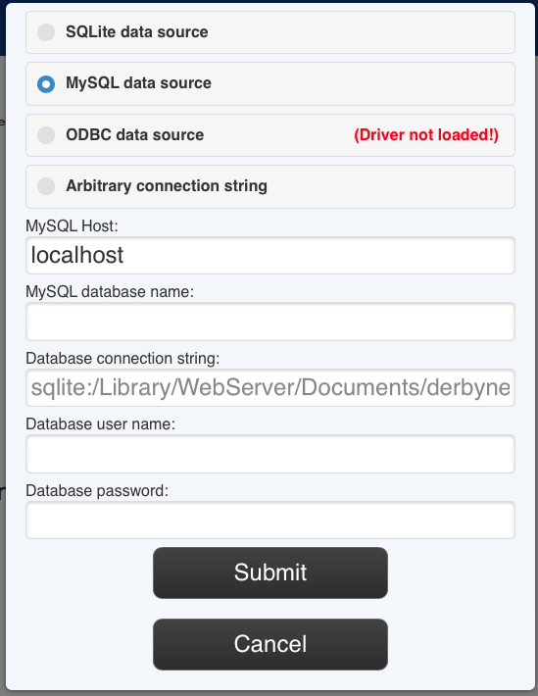
Clicking the Configure button brings up the database configuration dialog shown here. Choose “MySQL data source,” and enter the database name, user name, and password for the MySQL database you created.

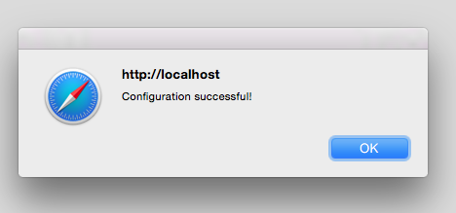
Click the “Submit” button, and you should see a confirmation that the database is correctly configured.

Initialize the Database Schema
Click "Initialize Schema". Despite the warnings, have no fears about initializing a database that’s empty to begin with!

Optional: Adjust User Roles
If desired, edit the file config-roles.inc that's now present in the local subdirectory (i.e., /Library/WebServer/Documents/derbynet/local/config-roles.inc) to change the roles, passwords, or permissions:
open -a TextEdit /Library/WebServer/Documents/derbynet/local/config-roles.inc

Optional: Remove Write Permissions
It's a good practice to remove write permissions from your 'local' subdirectory after initialization:
sudo chmod -R 755 /Library/WebServer/Documents/derbynet/local

